ZIMBABWE CONFERENCE OF SABBATH KEEPING ADVENTISTS
OUR FUNDEMENTAL BELIEVES
- Scriptures: As Christians we believe in the Bible and the Bible alone (Sola Scriptura). Embracing the totality of the scriptures (Both the Old and New Testaments) we subscribe to their inspiration by the Holy Spirit. The scriptures are our rule of faith and conduct as well as being the litmus test of any conviction and experience and any course of action we pursue. (2 Timothy 4:16; 2 Peter 1:20 ;)
- Second coming: We believe in the imminent return or second coming of Jesus which is the blessed hope and shall be the ultimate end to all the suffering of humankind. (Matthew 24:3-14; Luke 22; Titus 1:13) He’s coming will be personal, literal and visible. The righteous dead will be resurrected and the righteous living will be caught up together in the air to meet the Lord but the unrighteous living will perish. (1 Thess.4:16-17)The time of that event has not been revealed, and we are therefore exhorted to be ready at all times. (Matthew 24:42)
- The Law: We believe in the validity of all the commandments including the fourth one which is a reminder to the entire world to keep the Sabbath Day holy. The keeping of the commandments is a package deal. According to James 1:10-12 not one should be broken. Being the royal law, they are the transcript of Gods character and the weight by which we are measured in the judgement. Initially God gave four types of law to the Israelites. These were: Royal law (Ten Commandments); Ceremonial law; Civil Law and Health law. The ceremonial law was embodied in the sacrifices and ordinances which directed people to the sacrificial redemptive death of Christ. It met its fulfillment in the death of Christ and was nailed to the cross and therefore no longer binding. Civil law governed interpersonal relations among Gods children and has been carried over by national governments. The health laws are advocated in the health message we preach to the world.
- The Sabbath: We believe in the validity of the Sabbath (Saturday) which is the seventh day of the week. All the commandments are equally important and sacred and are not God’s opinions to mankind but His mandates to be obeyed. The Sabbath was not written for the Jews only and is equally relevant and universally binding like the commandment ‘Thou shalt not steal’. Exodus 16:11-28 bears testimony to the fact that it is a specific day. During the wilderness experience the Israelites gathered manna which was sufficient for the day. When they collected more to store for the following day with would rot, however, on the sixth day God always delivered a double portion of manna and they were allowed to pick an extra portion for the seventh day. The extra portion they picked for the Sabbath remained fresh. Therefore, there is only one day which God blessed and the position of the Sabbath is specific. Luke 23:53-56 and Luke 24:1 can help us to identify the true position of the seventh day of the week. In Luke 24:54 Jesus was buried on preparation day (sixth day) just before the Sabbath had begun. In celebrating Easter, the whole world calls this day ‘Good Friday’. Therefore, if Friday is the sixth day of the week Saturday becomes the seventh day. Furthermore, the day Jesus rose from the dead is called ‘Easter Sunday’ by the whole world. Luke 24:1 declares it was on the first day of the week. Therefore, Sunday is the first day of the week.
- The Holy Trinity: We believe in the one triune God; The Father, the Son and The Holy Spirit. The Son is God with us. The Holy Spirit is God in us. At the cross Jesus secured our salvation with the price of His blood. Today the Holy Spirit applies this provision by Christ to make it an efficacy in our lives. The Holy Spirit is the mediator of the unseen God. In a nutshell the Godhead (Father, Son and Holy Spirit) is a subject which was never meant to be fully understood by men. If we understood God fully, He would cease to be God.
- The Sanctuary message is the hub of Bible truth. The types in the Old Testament were the models or pictures through which we envision the anti-types (realities) in the New Testament. Psalm 77:13 “Thy way, O God, is in the sanctuary.”
- Judgement: The work of Judgement takes place in three phases which are; investigation, sentencing and the executive part of the judgement. The investigative or pre-advent judgement began on the 22nd of October in 1844. Our belief is substantiated by an understanding of Daniel 8:14 which reads: ‘Unto 2300 days then shall the sanctuary be cleansed’. The cleansing of the sanctuary is the work of the investigative judgement taking place in heaven. When Jesus comes, He will be holding the reward (for each person according to their works). For Him to conclude what reward each person deserves it means there was a preview into the person’s life via the evidences in the books of record in heaven. Thus, the status of every individual will be concluded before Jesus comes (sentencing will have been done). (Revelation 22:12; 2 Corinthians 10:5; Ecclesiastics 12:13-14; 1 Peter 4:17).
- Prophetic gift: We believe in the gift of prophecy given to the Remnant according to Revelation 12:17 and Revelation19:10. This gift has been manifested in the ministry and writings of Ellen G White. Her writings are an inspired commentary on the Bible and not another Bible. Her writings are a lesser light leading to the greater light.
- Righteousness by faith (or justification by faith. The Bible declares ‘our righteousness is like filthy rags... Isaiah 64:6. Man is naked spiritually. Covering is extended to us by Christ because of the merits of His blood. By pledging our faith in the merits of the blood of the Lamb of God we receive forgiveness of our sins (called justification). Justification is the work of a moment. God will then begin another work in us called sanctification. To be sanctified means to be made to become like Him in character or to be made holy. Justification is the imputed righteousness of Christ. To impute means ‘to credit to one’s account’. Sanctification is the imparted righteousness of Christ. In other word’s man needs an empowerment from Him to enable him to live a Christlike life.
- Systematic benevolence. God left a plan by which His work should be supported and the believers would be blessed and be cured of selfishness. This plan is biblically endorsed in the tithes and offerings which believers should bring to the house of God. (Malachi 3:8-12; Matthew 23:23) We are God’s stewards (managers), entrusted by Him with time and opportunities, abilities, possessions and the blessings of the earth and its resources. Returning to God what belongs to Him is essential in our personal growth as believers and for the growth of the church.
- State of the dead: Dead men cannot tell tales. The evidences are there in Ecclesiastes 9:5-6. At creation of man God combined two elements, the dust which was used to make the body and the breath of life which came from God. The two were blended and man became a living soul. Other translations say man became a ‘living being’ or person. At death there is a separation or detachment of the two elements and hence there will be no more ‘living soul’ or person to talk about. According to Psalms 146:4; Psalms 115:17 the body goes back to the dust of the ground and the spirit (breath of life) goes back to God. Death is an unconscious state for all people (or simply put - death is a sleep). When Christ, who is our life, appears, the resurrected righteous and the living righteous will be glorified and caught up to meet their Lord.John 5:28, 29; 11:11-14; Rom. 6:23; 16; 1 Cor. 15:51-54
- . The cleansing of the sanctuary: Gods way is in the sanctuary (Psalms 77:13). The Sanctuary is the text book from which God educated the people because the Bible had not yet been written. The articles of furniture within and all the services hosted foreshadowed Jesus. How were people forgiven in the past before the death of Jesus? Furthermore, the Bible stresses that the blood of the bulls and goats they sacrificed could not cleanse (Hebrews 9:22). The answer is in much the same way that you and I are forgiven. The blood of the lambs of sacrifice symbolized the blood of Jesus (John 1:29). During the Old Testament sacrificial offerings when the worshipper shed the blood of the lamb, he/she in essence was pledging faith in the unshed blood of Jesus. God honoured the faith and would then extend His covering upon the worshiper. The officiating priest would then take the blood of the lamb into the sanctuary to either smear on the horns of the altar or the veil separating the Holy place from the most Holy. The mark of blood constituted a ‘register or record’ of the sin. In the course of the year the records of the people’s sins accumulated in the Sanctuary. On the day of Atonement (Leviticus 16) the High Priest moved into the most Holy Place on behalf of the nation of Israel. On this day the records of the nation’s sins were ‘flushed out’ or blotted out in what was called the cleansing of the sanctuary. This was done so there would be a clean slate between God and His people. On the Day of Atonement, the forgiven sins of the people were blotted out.
- Forgiving and blotting out of sin: These are two very different processes which take place at different times. Today God can forgive your sin but it’s not blotted out yet. Psalms 32:1 declares ‘Blessed is he whose transgression is covered’. In other words, our sins are just covered under the blood of Christ. But why is it so? Here is an example: When you board a bus you purchase a ticket. You are still required to hold onto the ticket until you get to your destination. Losing your ticket can put you into trouble and cause you to be expelled by the bus inspector. In like manner God gives you your ticket called ‘justification’ when you accept His forgiveness and embark on the journey to Heaven. In the course of your Christian journey God will continue in you a process called sanctification. This is the process of a lifetime and must be completed. When the image of Christ is fully produced in us (sanctification) then we have acquired the fitness for Heaven. At this time God will consider that our sins be blotted out. You see some begin the race and they drop their ticket and decided to be out of the journey for good. Such can never get their sins blotted out.
- Antitype of Day of Atonement: Day of Atonement had to do with the flushing out of records of sin from the Sanctuary and the High Priest moved into the Most holy Place. Does God have books of record in Heaven? Yes. The Book of Remembrance according to Malachi 3:16. The Book of Life according to Rev3:5; Rev 13:8; Rev21:27. Is there a time when Jesus moved from the Holy Place of the Sanctuary in Heaven into the Most Holy, the judgement was set and the books of record were opened? Yes. Where do we find this? Daniel 7:9-10 records a scene which took place in Heaven.
The Bible declares: Dan 7:9-11 "I watched till thrones were put in place, and the Ancient of Days was seated; His garment was white as snow, and the hair of His head was like pure wool. His throne was a fiery flame; it’s wheels a burning fire; 10 A fiery stream issued and came forth from before Him. A thousand thousand ministered to Him; Ten thousand times ten thousand stood before Him. The court was seated, and the books were opened. NKJV
- The question is when did this take place? In other words when did the cleansing of the sanctuary begin? Daniel 8:14 declares: ‘Unto two thousand and three hundred years then shall the sanctuary be cleansed’. The answer to Daniel 8:14 is found in Daniel 9:20-27. In a nutshell to apply the prophetic timeline of the prophecy simply all we need to do is to find the starting point for the fulfilment. Verse 25 0f Daniel 9 is the keynote which exposes the starting point in the count of time with regards to the 2300 days. The command to restore and rebuild Jerusalem was issued in 457BC. A day in prophecy signifies a year (Ezekiel 4:6). To identify when the cleansing of the Heavenly Sanctuary began all we need to do is to add 2300 years to our starting point in 457BC. An extra year must be added to account for the transition year from BC-DC. This will take us to 1844.
- Here is a graphic explanation of the 2300-year prophecy.
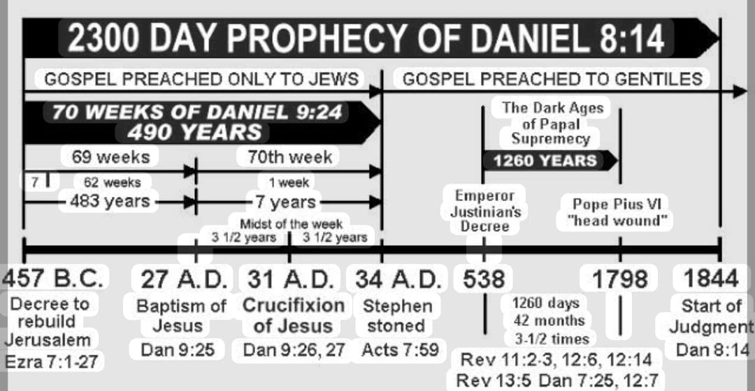
- A great religious awakening began in the mid 1830’s. William Miller believed Christ was going to come in 1844. Believers then were so agitated about the second coming of Christ. Many believers generally became known as Adventists because of the hype about the second coming. Christ never came as was anticipated so there was indeed a very great disappointment in 1844. The mathematical consideration of the prophecy was very correct but the interpretation pertaining to the fulfilment was grossly misunderstood. Some took it to prayer and a revelation was given to a believer named Hiram Edison. His saw in a vision Christ moving from the Holy place into the Most Holy in Heaven. Thus the conclusion of the whole matter was the event was something begun in Heaven and this was the investigative Judgement.
13. Three Angels message Rev 14:6-12 6 “Then I saw another angel flying in the midst of heaven, having the everlasting gospel to preach to those who dwell on the earth — to every nation, tribe, tongue, and people — 7 saying with a loud voice,"Fear God and give glory to Him, for the hour of His judgment has come; and worship Him who made heaven and earth, the sea and springs of water." 8 And another angel followed, saying,"Babylon is fallen, is fallen, that great city, because she has made all nations drink of the wine of the wrath of her fornication." 9 Then a third angel followed them, saying with a loud voice,"If anyone worships the beast and his image, and receives his mark on his forehead or on his hand, 10 he himself shall also drink of the wine of the wrath of God, which is poured out full strength into the cup of His indignation. He shall be tormented with fire and brimstone in the presence of the holy angels and in the presence of the Lamb. 11 And the smoke of their torment ascends forever and ever; and they have no rest day or night, who worship the beast and his image, and whoever receives the mark of his name." NKJV
What happened in 1844 was actually the beginning of the preaching of the first angels message to the world which talks about the hour of judgement. We conclude the investigative judgement began in 1844. The world is caught up in a false worship system called Babylon in scripture and is characterized by confusion. We are in the dispensation of the third angels message and we should warn people to come out of Babylon and prepare to be receive the seal of God (Ephesians 4:30) which is opposed to the mark of the beast. Whilst Christ is in the Most holy place interceding for us it means we have hope of being redeemed. We are leaving in probationary time. One of these days God shall close the door of probation. We find this in Revelation 22:11. Then it will be too late to seek for change. These messages are what we call present truth because they are relevant to the solemn times we live in. On the day of atonement people afflicted their souls or searched their hearts and confessed and forsook sin to make sure they were right with God. Whilst the High Priest was in the most Holy there remained hope of salvation to the penitent. The moment the High Priest departed from the Most Holy Place it meant that a permanent line was now drawn between the penitent and impenitent. The impenitent got cut out from being a part of Gods congregation.
Read Revelation 15:8 onwards to chapter 16. How do we know Christ is still in the Most Holy interceding for us? When Jesus steps out of the most Holy the seven last plagues will start to fall. The plagues will be universal and will touch only the unsaved.

